2025 IEEE CIS Student Grand Competition
Computational Intelligence in Biomedicine and Healthcare

The Challenge
With the development of the computational intelligence (CI) methods, novel applications including smart medicine, smart healthcare and smart hospital attract more and more attention in research, society, and industry.
CI/AI technology has played a significant role to assist medical professionals and their patients.
This hackathon looks forward to an CI/AI-driven tribute to smart medicine.
We welcome participants to present computational intelligence solutions for core issues in smart medicine, smart healthcare and smart hospital including but not limited to personalized, predictive, preventive and participatory medicine and healthcare solutions.
In the hackathon, we would like to address how CI/AI techniques can help the modern hospitals and humans with new and different approaches, and how CI/AI will change medicine/healthcare in the future.
Developers of all backgrounds and skill sets are welcome to join this hackathon.
The choice of technology is optional.
We are waiting for your participation.

Call for Proposals
The contest is open to all undergraduate or graduate students at accredited colleges or universities worldwide.
A team may consist of up to 6 eligible students and up to 2 mentors due to the cooperations of CI and medical domains.
*Commercial products are not allowed to be entered in the contest.

For detailed submission rules, please refer to the website.
https://sites.google.com/view/cissgc-2025/

Prize Per Team
In the final contest,
1st Place Award: $2,000 USD + Certificate
2nd Place Award: $1,500 USD + Certificate
3rd Place Award: $1,000 USD + Certificate
Honorable Mention : Certificate
* All cash price awards are before tax

Important Dates
Submission Due Feb. 28, 2025
Preliminary Contest Mar. 15, 2025
Final Contest Aug. 20, 2025

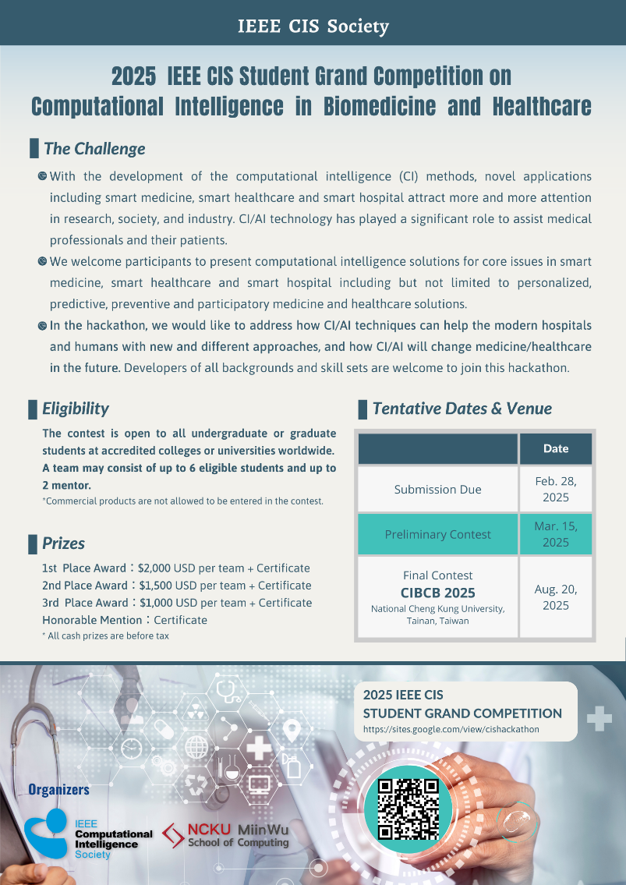

Organizers
IEEE CIS society
Miin Wu School of Computing, National Cheng Kung University, Taiwan

